|  |  |  |  |  |  |  |
| --- | --- | --- | --- | --- | --- | --- |
| North South University  Department of Electrical & Computer Engineering  LAB REPORT  Course Code : EEE/ETE 312 L Course Title: Power Electronics Lab Course Instructor:  Experiment Number:   |  | | --- | | Experiment Name: Study of the Power Thyristor (SCRs) |   Date of Experiment: 24/11/2020  Date of Submission: 27/11/2020  Section: 01  Group Number: 01 | | | | | |
| Submitted By | | | | | Score |
|  | | | | |  |
|  |  | Student Name | ID |  |
| 1. | Mohammed Mahmudur Rahman (Author) | 1520386043 |
| 2. | Md Alamin Biswas | 1411691643 |
| 3. | Md. Shahidul Islam | 1631781043 |
| 4. | Mehedi Hasan | 1611230043 |
| 5. | Md. Sharuar Zahan | 1431048043 |

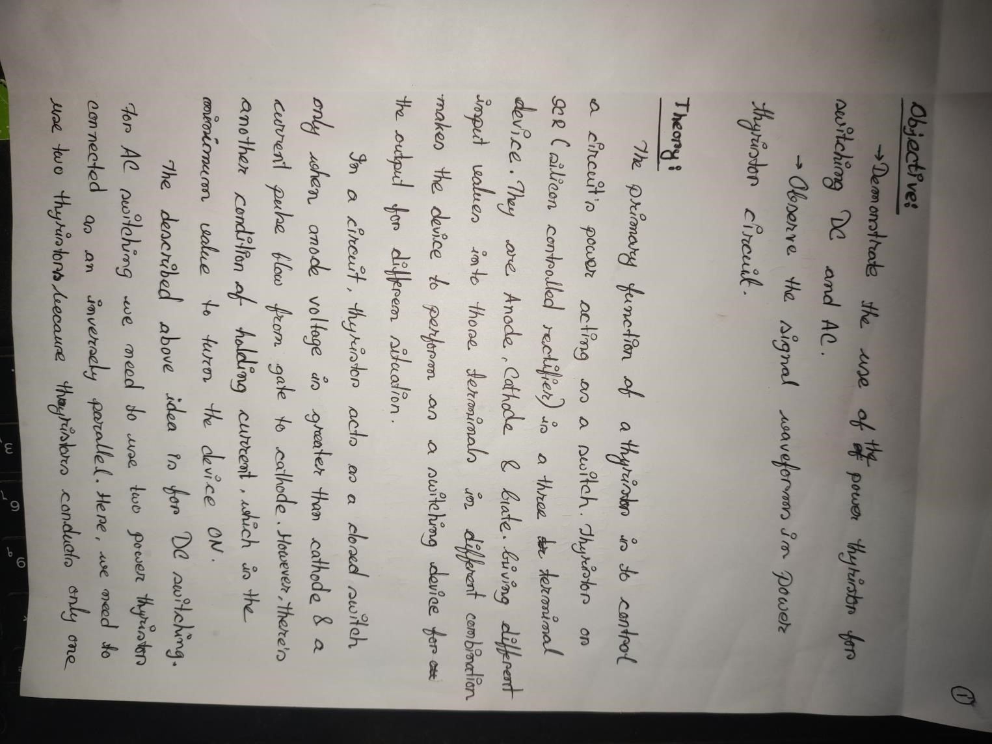

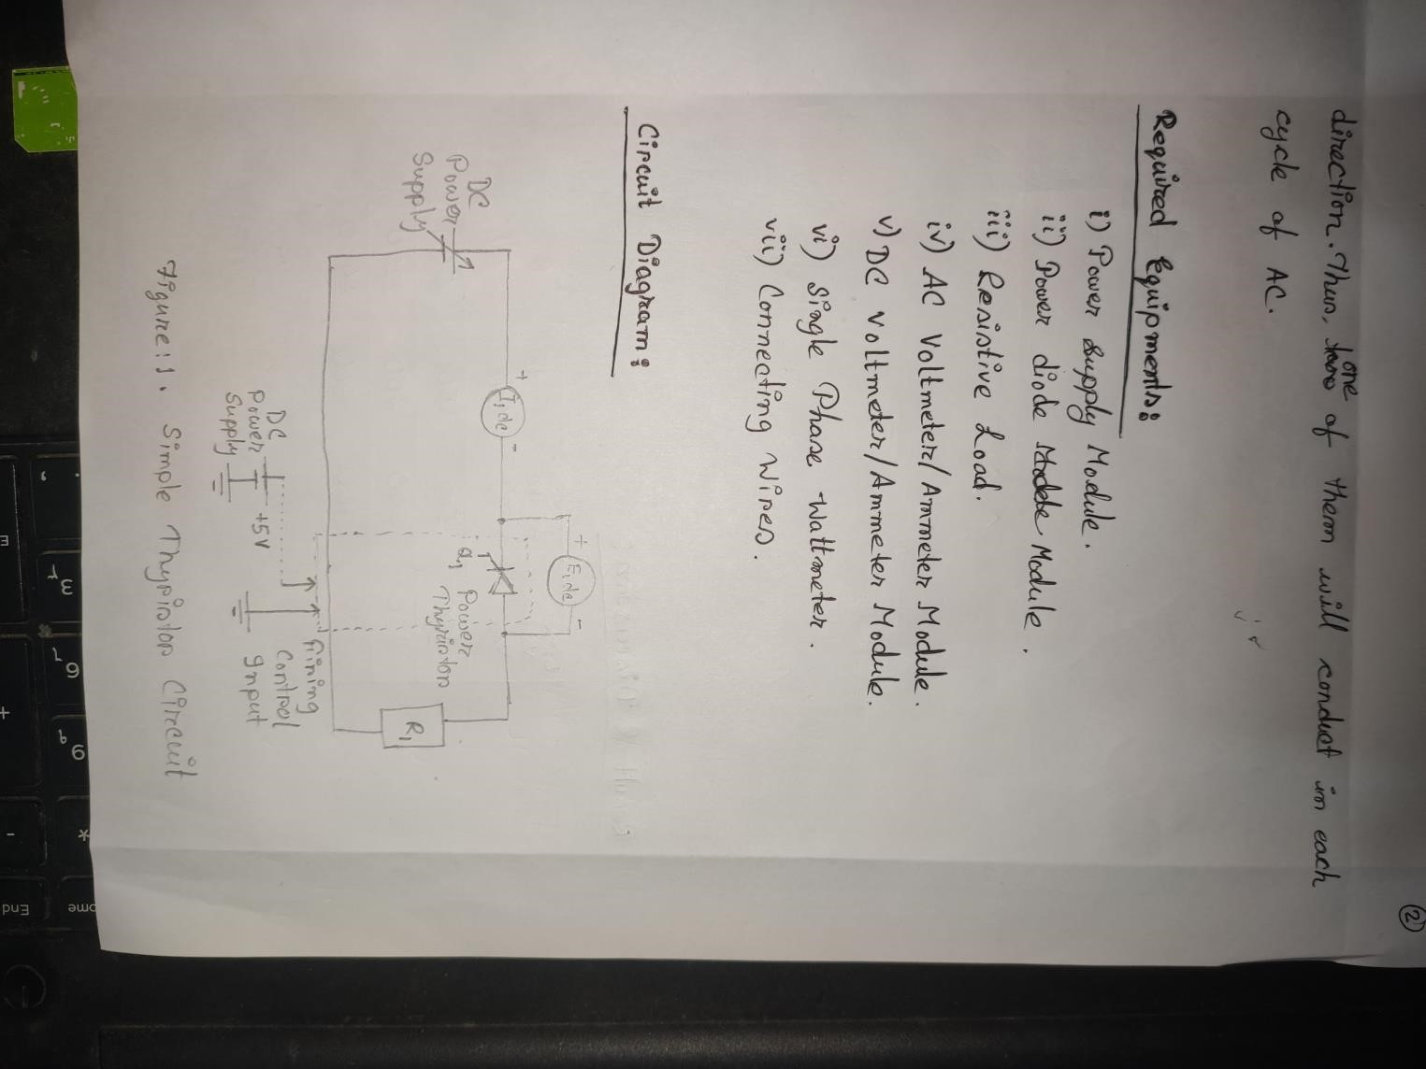

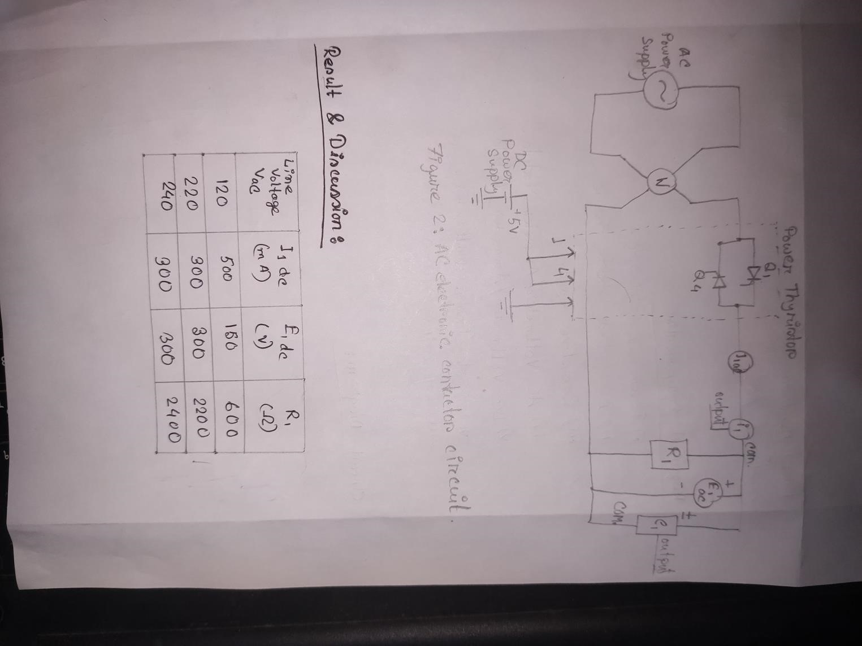

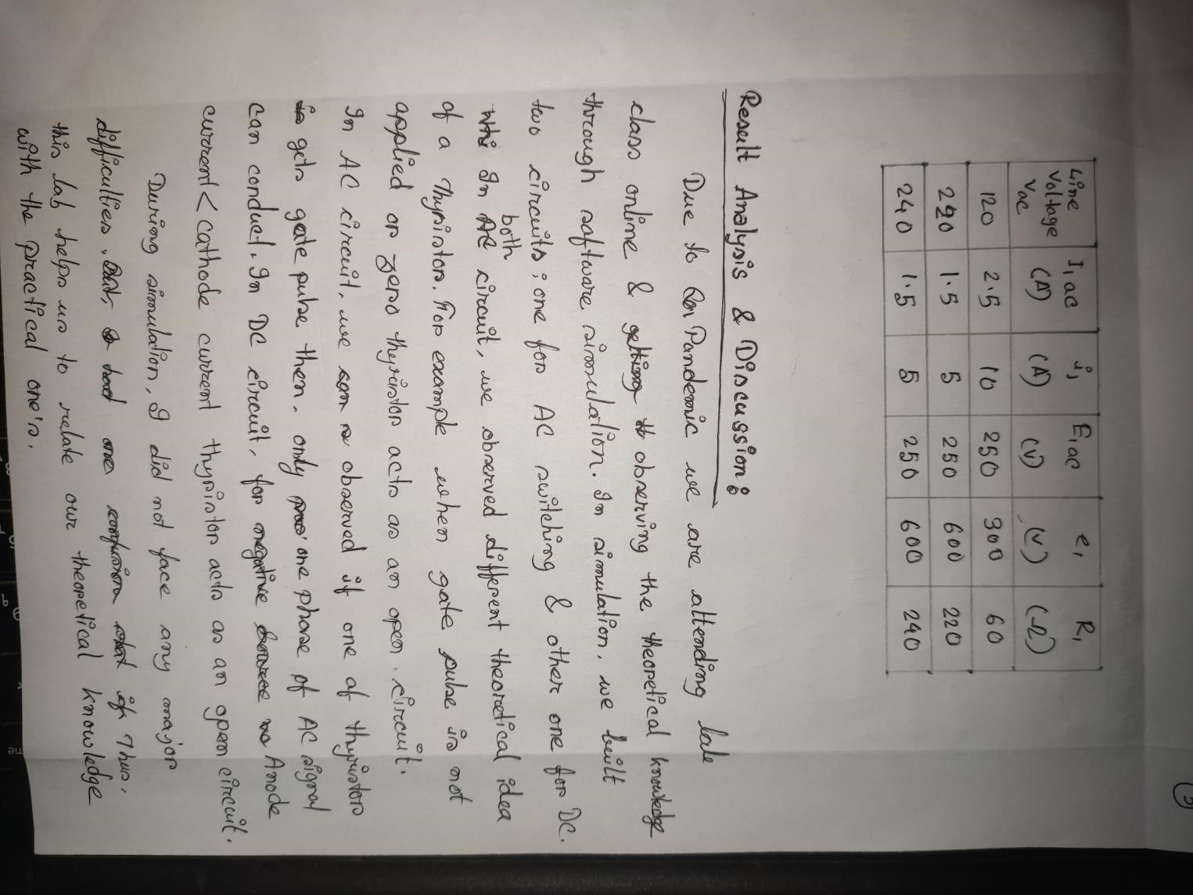

Gate voltage 0 in both circuit:

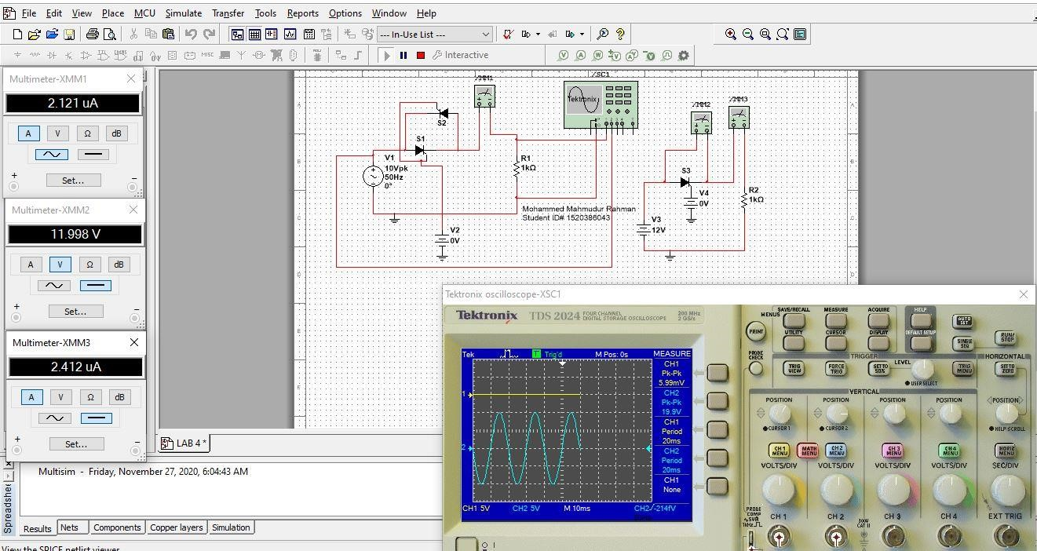

Source voltage negative for DC Circuit:

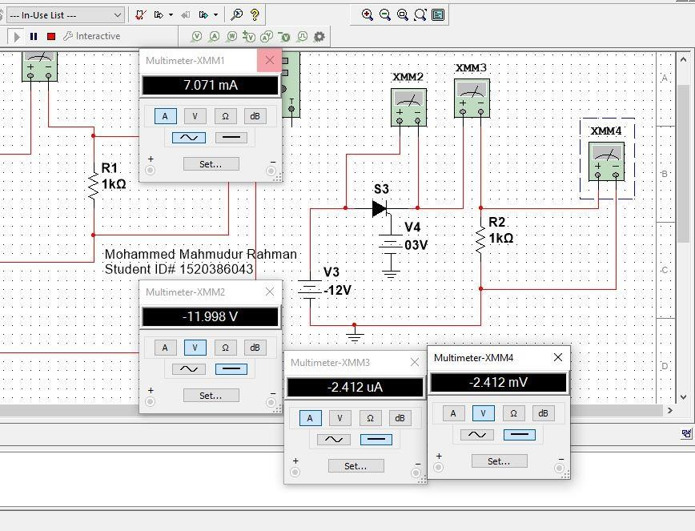

Gate pulse applied to one Thyristor:

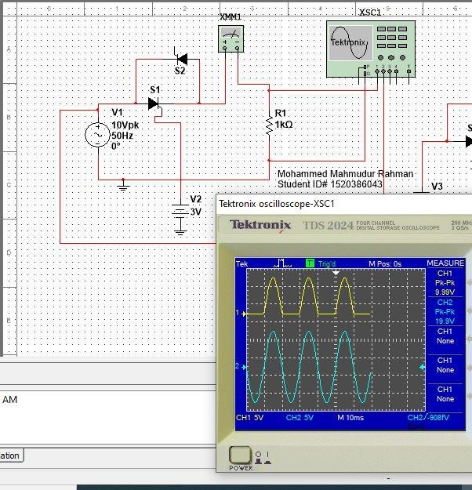

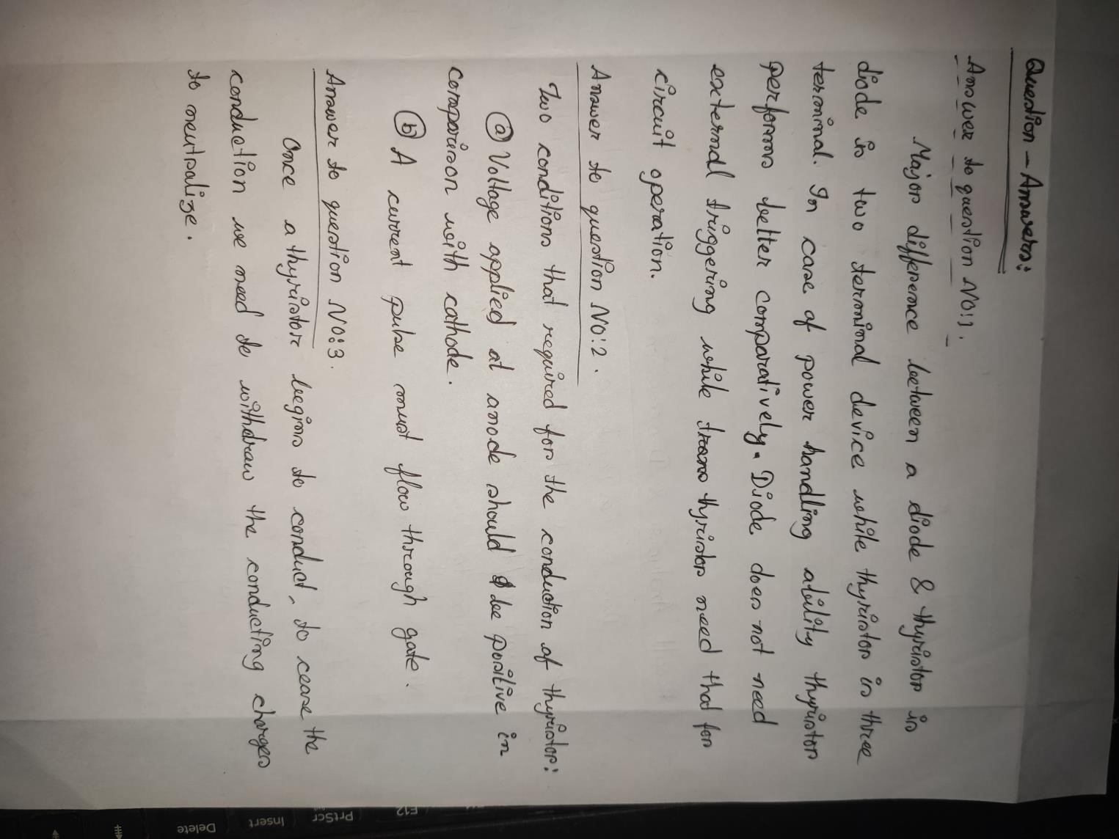

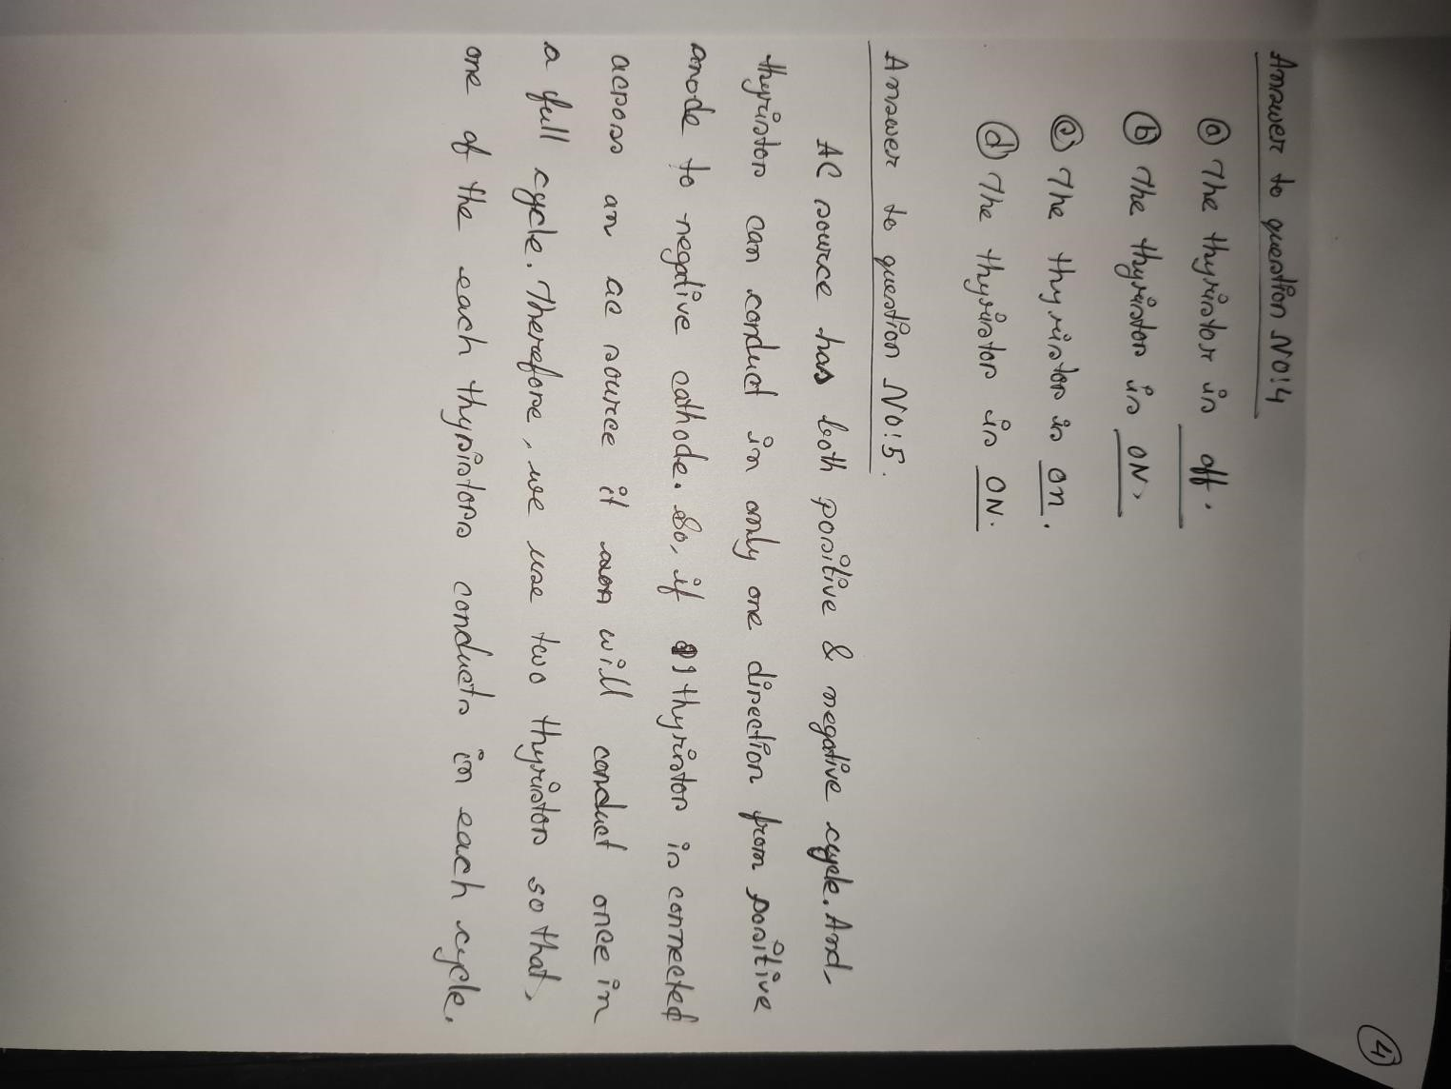

Attachments:

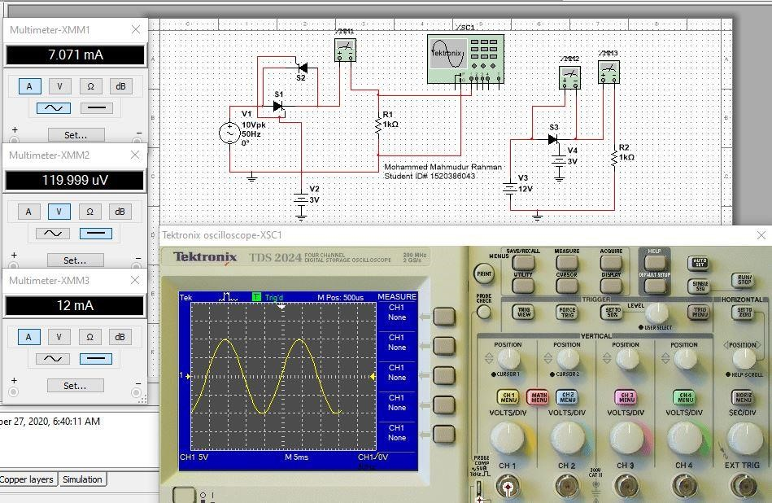

Figure 1: Mohammed Mahmudur Rahman Simulation

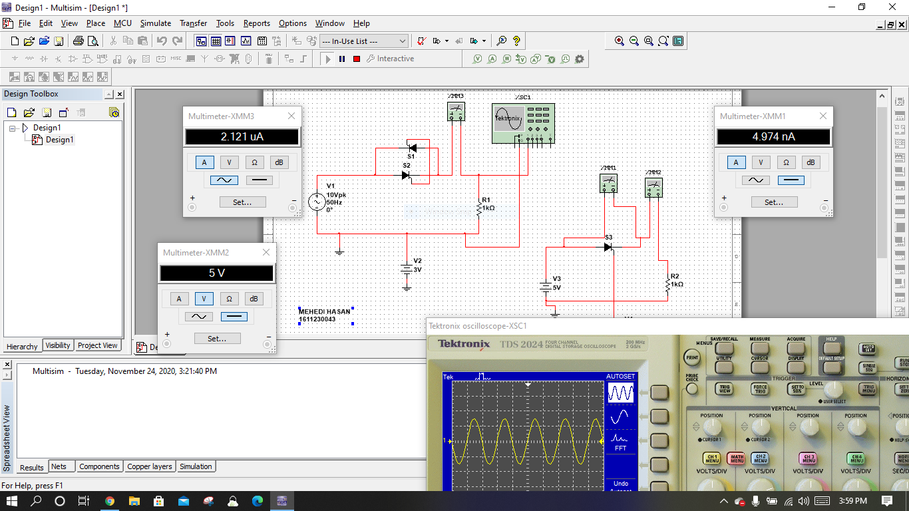

Figure 2: Mehedi Hasan Simulation